# Personal Pronouncer

With this app people will be helped in pronouncing the language English perfectly

This app is made in android studio and can run in any android device above android 3.0

This app uses the text to speech and speech to text by Google

With this we can give input in two ways by entering the word or by saying the word

Start Screen

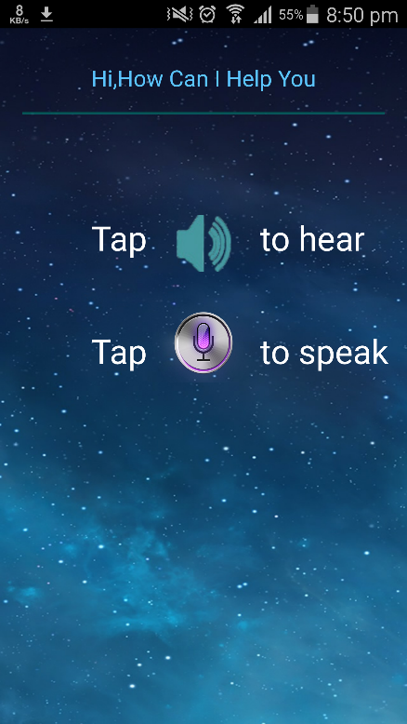

Manually entering the word

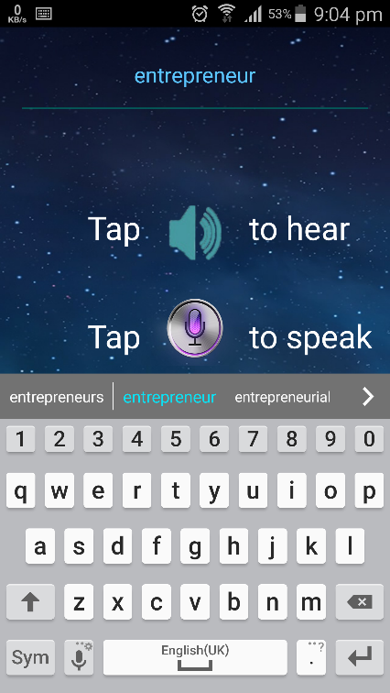

Voice input with Google speech to text

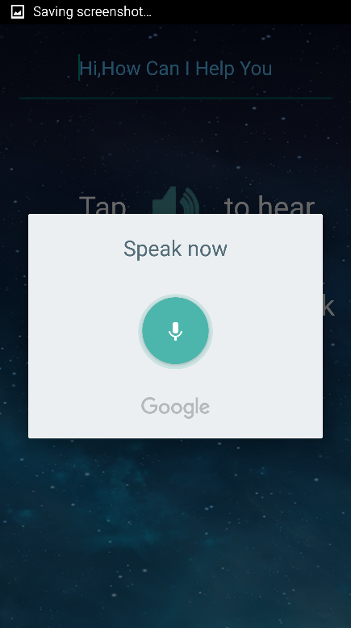

Word received is entrepreneur

